- Improved description of the solution to be implemented
- Functional
  - Alert the user when the temperature is hot
  - Alert the user of the distance to the surface
- Non-Functional
  - Comfortable
  - Does not interfere with the user
  - Will not break
- Constrains
  - Wire management may be an issue
  - The orientation of the user’s hand will have an effect on the functionality
  - The user may burn themself if the glove does not protect them properly
Table
Input | Output | Purpose
Temperature Sensor | Buzzer | Will alert the user if the temperature is above a comfortable level, to ensure that the user does not burn themself.
Ultrasonic Range Sensor | Vibrator | Will alert the user the distance to the surface through the feedback of a vibrator, the intensity and frequency of vibrations will alert the user of the distance.

Inputs:
- Temperature Sensor
- Ultrasonic Range Sensor
Outputs:
- Vibrator (To alert user of the distance to the surface of an object)
- Buzzer (For sound to alert the user when the temperature is hot)

- Refine the sketch of your product.
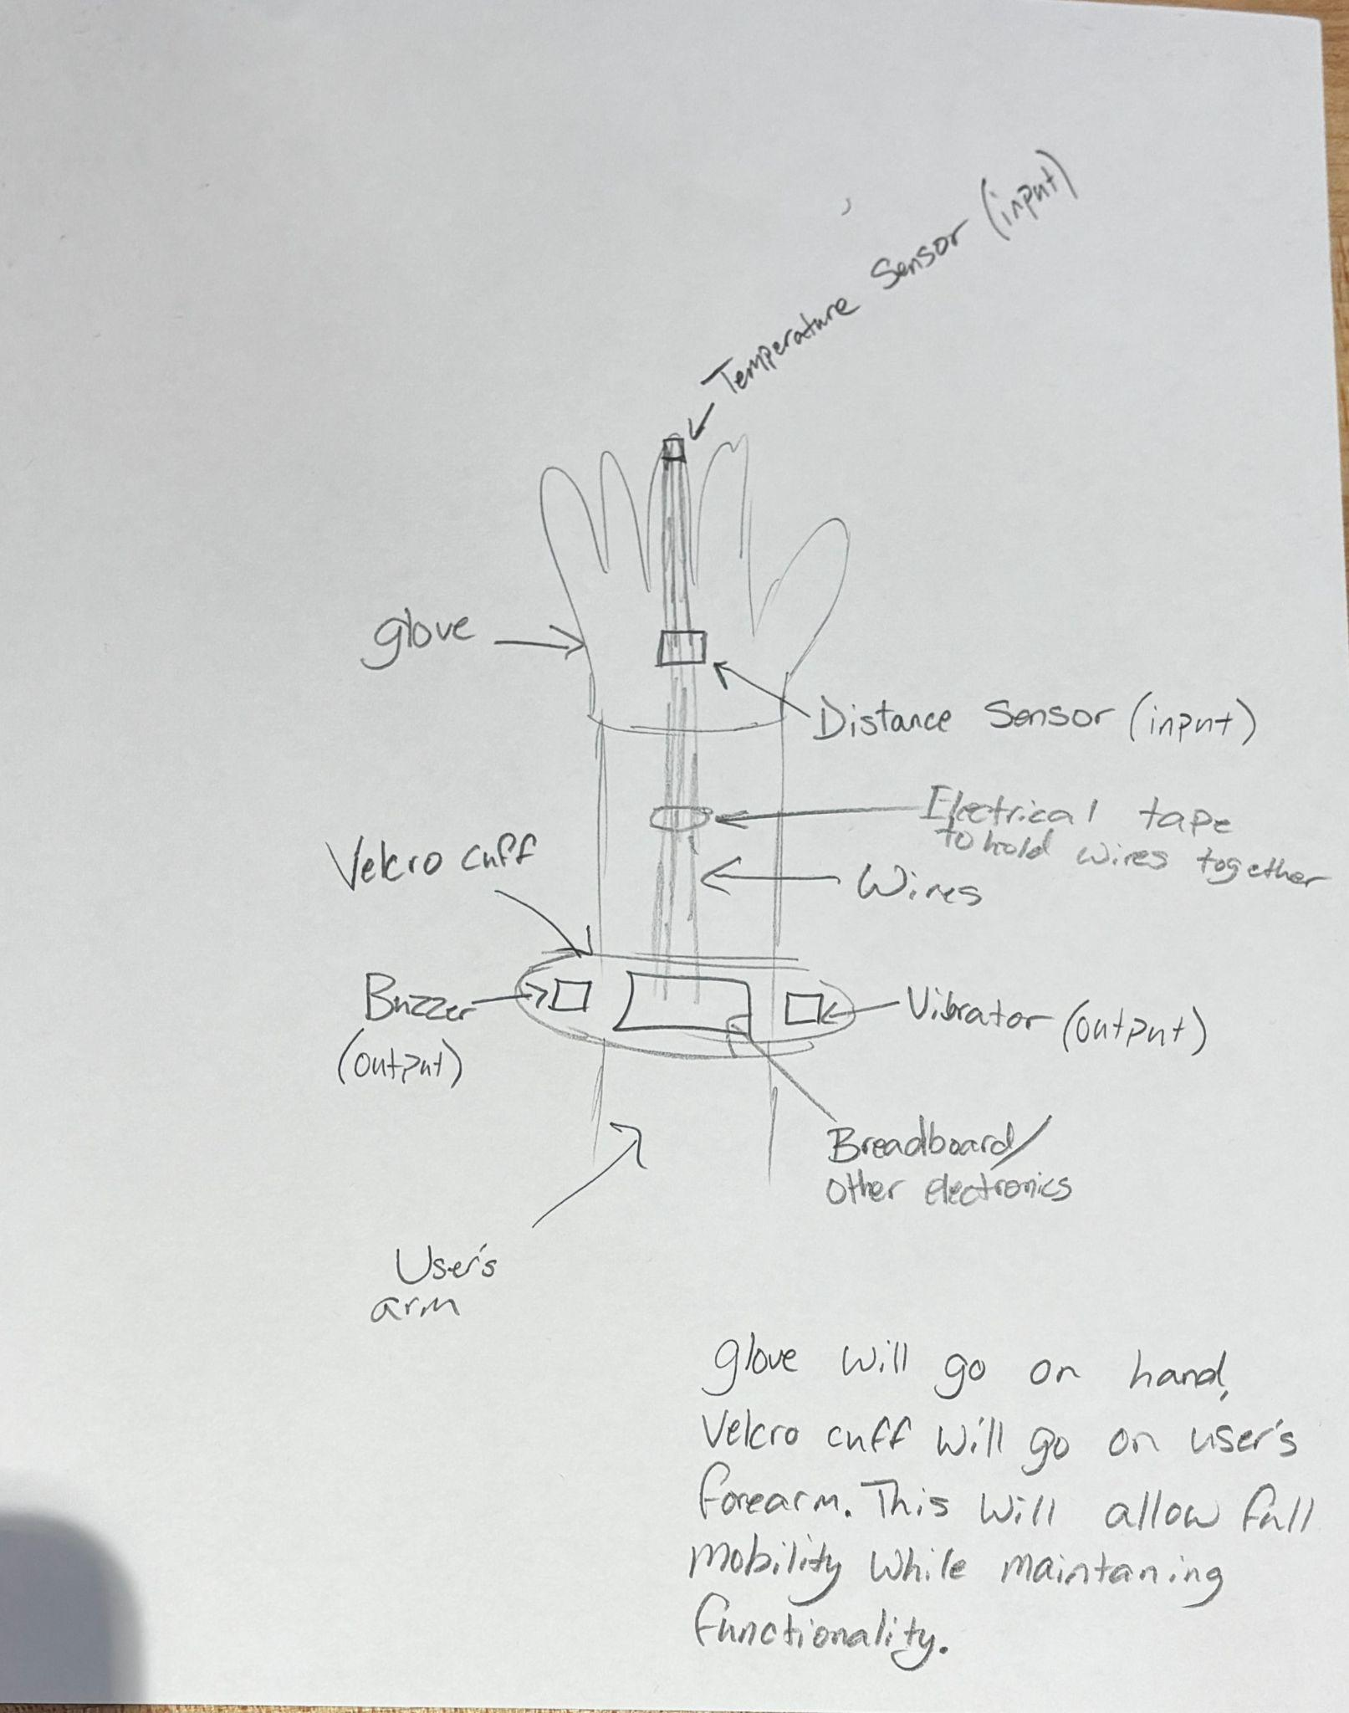
3. Define use cases to test your product
- Use Case 1:
  - Name: Check Glass Top Stove Temperature
  - Actors: Visually Impaired Person
  - Goals: The goal is to be able to check the temperature of a glass top stove without burning yourself.
  - Procondition: The person wears the glove.
  - Description:
    - 1. The person approaches the stove
    - 2. The vibrators on the palm of the glove will vibrate when the Ultrasonic sensor detects that the user's hand is within 5cm of the stove top.
    - 3. The person reaches and touches the stove with the tip of their middle finger which has the temperature sensor.
    - 4. Depending on the temperature of the stove, the buzzer will alert the user of the temperature (the buzzer will go off in intervals for a lower temperature and solid for a higher temperature).
    - 5. If the feedback indicates that the stove isn’t hot enough, the user will adjust the temperature of the stove. The buzzing frequency from step 4 will give the user an idea of the temperature range the stove is at.
    - 6. Repeat step 3 and 4 until desired temperature is reached

- Name: Cook a steak
- Actors: Visually impaired person
- Goals: To cook a steak on a stove
- Precondition : The person wears the device
- Description of the steps:
- The person approaches a stove
- Vibrator in the palm of the glove vibrates after the ultrasonic sensor detects an object within 5cm.
- The person reaches towards the stove top with a glove.
- The person should touch the steak for X seconds of time with their index finger that has the temperature sensor.
- The temperature sensor detects temperature and informs the user through buzzer (the user will determine the temperature through the duration of the buzz)
- The person will determine if the steak is cooked based off of the temperature read
- If uncooked repeat steps 4-6
4. Define the state diagram showing how the product works, make sure that you include all the behavior of all different sensors/inputs and feedback/outputs
